Basic Fashion Figure
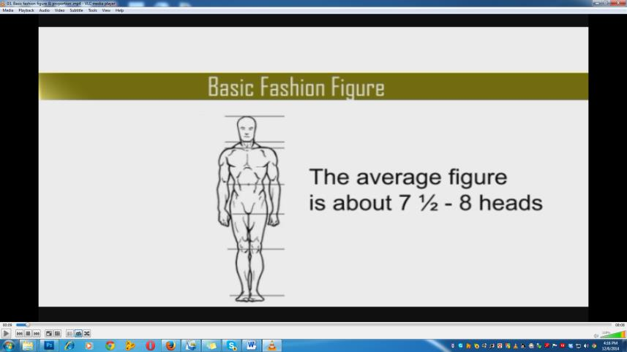
There’s a big difference between proper body proportions in art and in fashion.
The body’s proportions are measured in heads. The average figure is about 7 ½ - 8 heads, including the actual head, tall.
However, in fashion, the body proportions are elongated in order to better represent the models. Because of this, the figures become 8-10 heads tall.
How to draw Fashion Figure
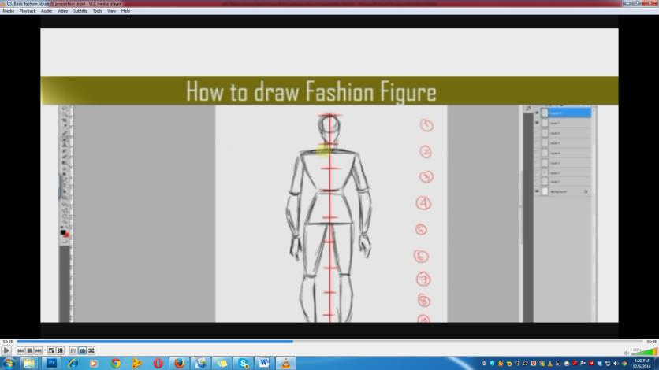
Draw a line. This is the balance line, the line which determines the body’s center of gravity. It should be a straight vertical line.
Draw a head with the middle of it on the line. To draw a head, sketch a circle / oval on top.
Measure the head, either with your pencil or the ruler. Using this measurement, draw nine small dashes equal distance apart, then number these segments from the bottom of the chin (#1) down to the bottom of the feet (#9).
Now, we will draw segment by segment that means #1 to #10.

1st Head
here you already drawn the Face.
2nd Head
Draw the Neck and the shoulder. The shoulders are 1 1/2 heads wide,
3rd Head
Draw Bust and waist. The waist will be a head’s width in the bottom of the 3rd segment.
The elbows are also located with the waist at the 3 heads mark.
4th Head
Draw the Pelvis. The hip should be about 1 1/4 heads wide.
For the lower half of the body, mark 6 1/2 heads as well as mark 9 for the knees and ankles, respectively.
Draw the legs by making lines which curve and narrow as they go from the high hip to the knee for the thighs. For the calves, make a smaller cylindrical shape by curving the lines from the knees and then tapering them at the ankles, which jut out slightly on the inner half of each leg.
The thighs (from high hip to knee) and the calves (from knee to ankle) should be the same length.

The last head is for the feet, which begin at the ankle to flare out in diagonal lines for 3/4 of the length of the head before they meet at a point.
Draw the hands similarly. These begin with the wrist at the crotch. The fingers should end a little above the 5 heads mark.
How to Choose a Good Pose for Your Fashion Drawings
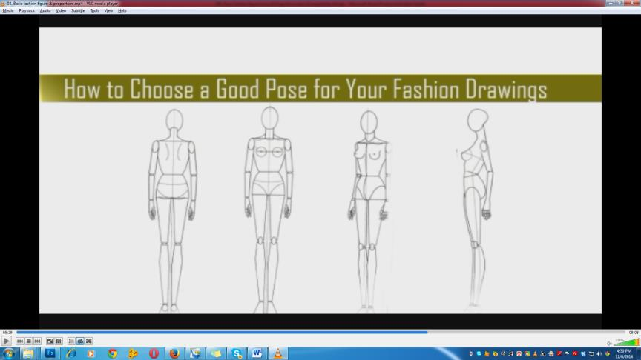
Not all poses you see on real-life models translate well onto paper, but it’s helpful to recognize different poses and understand what types of poses work well with different types of clothing.
A fashion model in an evening dress/ Shari doesn’t strike the same poses as a teen dude in an urban outfit. The fashion model stands tall and straight to show off the gown’s bodice and the teen dude is likely to assume a slouched pose to demonstrate how the clothing moves with easy over his body.
In fashion illustration, you utilize four different views of poses for most of your artwork:
- The back view (a)
- The front view (b)
- The three-quarter view (c)
- The side view (d)

To draw a basic fashion figure, you must first understand what a “good” pose is. When drawing fashion poses, follow these informal rules:
- Make sure your model isn’t leaning on anything. She should be standing on her own two feet.
- Keep your model from falling over on the page. You create balance by keeping the head, shoulders, hips, knees, and feet in a straight line from head to toe.

Angle the shoulders in one direction and the hips in the opposite direction. Doing so gives the impression of movement and attitude — two must-haves in fashion drawing.

